// =======================

// Attached: Hw 6 A,B,C,D,E

// =======================

// HW 6A

// =======================

// Youssef Abdelwahab

// CS 1B

// =======================

#include <iostream>

#include <iomanip>

#include <string>

#include <cmath>

#include <fstream>

using namespace std;

int main()

{

ifstream numbers("data.txt");

int number;

cout << "Here are the numbers in the file: " << endl;

while (!inFile.eof())

{

Numbers >> number;

cout << number << endl;

}

if (!numbers.is_open())

{

cout << "Error opening file";

}

system("pause>null");

return 0;

}

// =======================

// Attached: Hw 6 A,B,C,D,E

// =======================

// HW 6B

// =======================

// Youssef Abdelwahab

// CS 1B

// =======================

#include <iostream>

#include <iomanip>

#include <string>

#include <cmath>

#include <fstream>

using namespace std;

int main()

{

int number;

ifstream data("data.txt");

ofstream results("Results.txt");

while (!data.eof())

{

data >> number;

results << number << endl;

}

cout << "The data has been written." << endl;

if (!data.is_open())

{

cout << "Error opening file";

}

system("pause>null");

return 0;

}

// =======================

// Attached: Hw 6 A,B,C,D,E

// =======================

// HW 6C

// =======================

// Youssef Abdelwahab

// CS 1B

// =======================

#include <iostream>

#include <iomanip>

#include <string>

#include <cmath>

#include <fstream>

using namespace std;

int main()

{

int number;

ifstream resultsin("Results.txt");

ofstream resultsout("Results.txt", ios::app);

while (!resultsin.eof())

{

resultsin >> number;

cout << number << endl;

}

cout << "Please enter 3 more numbers: " << endl;

for (int i = 0; i < 3; i++)

{

cin >> number;

resultsout << endl << number;

}

cout << "The numbers have been written (appended) to results.txt." << endl;

if (!resultsout.is_open())

{

cout << "Error opening file..";

}

system("pause>null");

return 0;

}

// =======================

// Attached: Hw 6 A,B,C,D,E

// =======================

// HW 6D

// =======================

// Youssef Abdelwahab

// CS 1B

// =======================

include <iostream>

#include <iomanip>

#include <string>

#include<fstream>

#include <cmath>

using namespace std;

struct cat

{

char name[50];

int age;

};

int main()

{

fstream file;

cat Cats;

file.open("critters.bin", ios::binary | ios::out);

cout << "Enter 3 cat records: " << endl;

int times = 0;

while (times < 2000)

{

cout << "Enter information about a cat: " << endl;

cout << "Name: ";

cin >> Cats.name;

file.write((char*)&Cats.name, sizeof(Cats.name));

cout << "Age: ";

cin >> Cats.age;

file.write((char*)&Cats.age, sizeof(Cats.age));

if (times >= 2)

{

break;

}

else

{

times += 1;

continue;

}

}

cout << "Record has been written to file." << endl;

system("pause>null");

return 0;

}

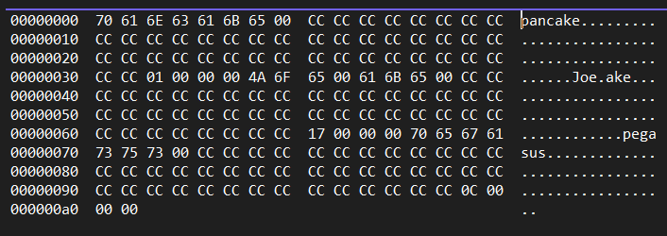

// =======================

// Attached: Hw 6 A,B,C,D,E

// =======================

// HW 6E

// =======================

// Youssef Abdelwahab

// CS 1B

// =======================

#include <iostream>

#include <iomanip>

#include <string>

#include<fstream>

#include <cmath>

#include <vector>

using namespace std;

struct cat

{

char name[50];

int age;

};

int main()

{

fstream file;

cat Cats;

file.open("critters.bin", ios::binary | ios::out);

cout << "Enter 3 cat records: " << endl;

int times = 0;

while (times < 2000)

{

cout << "Enter information about a cat: " << endl;

cout << "Name: ";

cin >> Cats.name;

file.write((char*)&Cats.name, sizeof(Cats.name));

cout << "Age: ";

cin >> Cats.age;

file.write((char*)&Cats.age, sizeof(Cats.age));

if (times >= 2)

{

break;

}

else

{

times += 1;

continue;

}

}

cout << "Record has been written to file." << endl;

file.close();

file.open("critters.bin", ios::binary | ios::app);

cout << "Enter information about a cat: " << endl;

cout << "Name: ";

cin >> Cats.name;

file.write((char*)&Cats.name, sizeof(Cats.name));

cout << "Age: ";

cin >> Cats.age;

file.write((char*)&Cats.age, sizeof(Cats.age));

file.close();

file.open("critters.bin", ios::binary | ios::out);

int times2 = 0;

while (times2 < 2000)

{

file.read(Cats.name, sizeof(Cats.name));

cout << setw(10) << left << Cats.name << endl;

file.read(reinterpret_cast<char*>(Cats.age), sizeof(Cats.age));

cout << Cats.age << endl;

if (times2 >= 3)

{

break;

}

else

{

times2 += 1;

continue;

}

}

system("pause>null");

return 0;

}

